EIGRP x OSPF Route Redistribution

Mason and Hoffman – Period 6-8

Jeffrey Zhang

Purpose

The purpose of this lab was to strengthen our fundamentals in redistribution between OSPF and EIGRP protocols. Also, we’ll learn how to merge multiple protocols in a network for traffic to flow through with redistribution.

Background  
Imagine OSPF and EIGRP as 2 different languages. These two languages can’t communicate with each other directly within a network. Route redistribution is when you take a route from one routing protocol and distribute it into another protocol. Continuing with the language analogy, it is when you By default, routers only advertise and share routes with other routers running the same protocol. It is like the shared location between the two networks that translates protocols and routes. Usually, it is only needed in larger networks. For example, if one interface on a router is running OSPF, and the other interface is running EIGRP, we must advertise the routes of OSPF into EIGRP so that the routes learned by these routing protocols are advertised with each other. Something that is very important is that different routing protocols use different metrics to find the best path, when we redistribute routes from one routing protocol to another, we must define the metrics.

Lab Summary

In this lab, we had to setup different routing protocols on different areas on different networks. We had to redistribute them with specific metrics. We had to have an interior AD of 90 and exterior as 105. We also had to have the reliability of 245 with a 900-tick delay.

Below, we have several screenshots of the command prompt upon successful deployment of the redistribution. These screenshots demonstrate successful attempts in redistributing traffic beginning as one source to be translated into another source. These were captured largely on routers and the command prompt built in windows 10 enterprise.

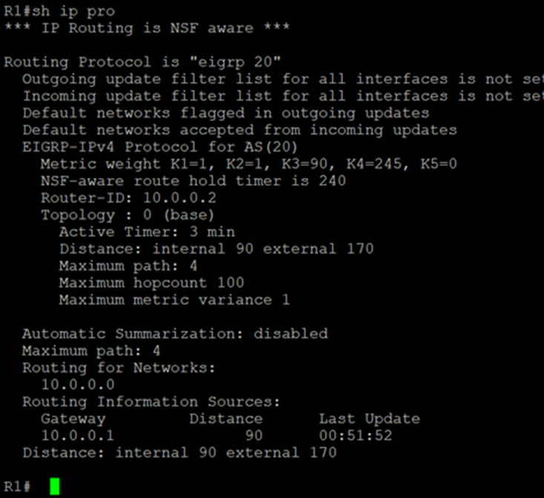

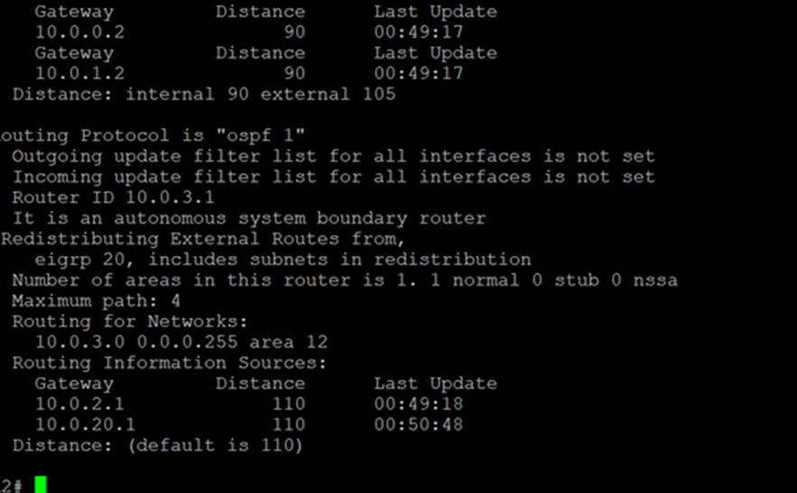

Above, we have router 1, below, we have routers 3 and 4.

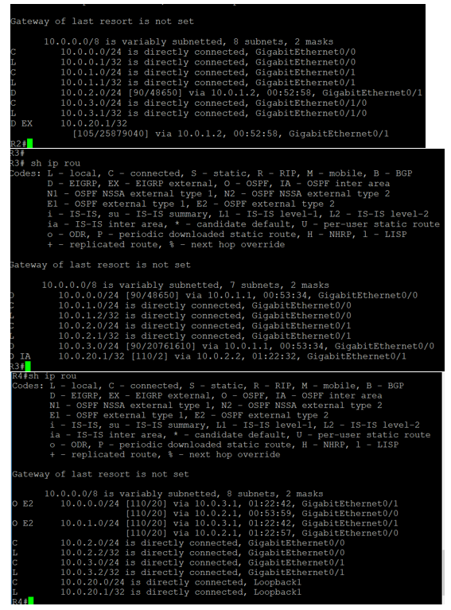

Configurations

Below is the **router** configuration for the routers utilized within the topology.

R1:

conf t

hostname R1

int g0/1

ip add 10.0.0.2 255.255.255.0

no shut

router eigrp 20

metric weights 0 1 1 90 245 0

network 10.0.0.0

R2:

conf t

hostname R2

int g0/0

ip add 10.0.0.1 255.255.255.0

no shut

int g0/1

ip add 10.0.1.1 255.255.255.0

no shut

int g0/1/0

ip add 10.0.3.1 255.255.255.0

no shut

router eigrp 20

metric weights 0 1 1 90 245 0

network 10.0.0.0

network 10.0.1.0

redistribute ospf 1 metric 1000 900 245 255 1

distance eigrp 90 105

router ospf 1

redstribute eigrp 20 subnets

network 10.0.3.0 0.0.0.255 area 12

R3:

conf t

hostname R3

int g0/0

ip add 10.0.1.2 255.255.255.0

no shut

int g0/1

ip add 10.0.2.1 255.255.255.0

no shut

router eigrp 20

metric weights 0 1 1 90 245 0

network 10.0.1.0

redistribute ospf 1 metric 1000 900 245 255 1

distance eigrp 90 105

router ospf 1

redistribute eigrp 20 subnets

network 10.0.2.0 0.0.0.255 area 15

R4:

conf t

hostname R4

int Loopback1

ip add 10.0.20.1 255.255.255.0

int g0/0

ip add 10.0.2.2 255.255.255.0

no shut

int g0/1

ip add 10.0.3.2 255.255.255.0

no shut

router eigrp 20

metric weights 0 1 1 90 245 0

distance eigrp 90 105

router ospf 1

area 15 range 10.0.2.0 255.255.255.0

area 12 range 10.0.3.0 255.255.255.0

network 10.0.2.0 0.0.0.255 area 15

network 10.0.3.0 0.0.0.255 area 12

network 10.0.20.0 0.0.0.255 area 0

Problems

This was a very simple and straightforward lab, so we didn't have any significant problems or major issues that require addressing. The only thing we struggled a little bit was with the metric weights. Initially we didn't know what K - values are and how to set the metric weights. It took a little research before we could finish the lab. Other than a minor research issue we didn’t have any other issues. (This might be one of our smoothest labs!)

Conclusion

In this lab, we accomplished our goal of improving our fundamentals in redistributing routes. I learned that redistributing is very important in real life because not all the networks will have the same protocols and will have more diverse protocols, and redistribution can be the most important thing to get everything working, due to the diversity of network topologies within the real world and how there could be various different network protocols within the same topology. What we learned here could be used to help translate more routes within complex topologies to streamline the speed of the packets.